[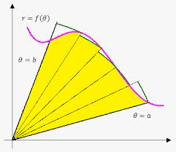](http://www.google.com/imgres?sa=X&rls=com.microsoft:en-us:IE-SearchBox&biw=1280&bih=843&tbm=isch&tbnid=bYHGk7ePiMSVWM:&imgrefurl=http://www.emathhelp.net/notes/calculus-2/applications-of-integrals/area-in-polar-coordinates/&docid=Hv-GQsCEaAAxOM&imgurl=http://www.emathhelp.net/images/calc/6_1_polar_area.png&w=349&h=303&ei=spAYU7vZO47JkAerrIEo&zoom=1&iact=rc&dur=640&page=1&start=0&ndsp=21&ved=0CIoBEK0DMBI)Finding area inside Polar Regions

Remember to find area under a curve you add up an infinite number of rectangles

[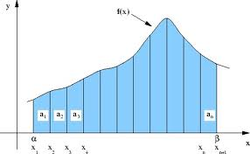](http://www.google.com/imgres?sa=X&rls=com.microsoft:en-us:IE-SearchBox&biw=1280&bih=843&tbm=isch&tbnid=hmEI7QxxW8_YMM:&imgrefurl=http://www.pleacher.com/handley/lessons/calc2004/day93.html&docid=Ua1469UXeVOEAM&imgurl=http://www.pleacher.com/handley/gifs4/area1.jpg&w=552&h=340&ei=KZEYU5eSNou2kQeRtYDwAw&zoom=1&iact=rc&dur=2672&page=1&start=0&ndsp=20&ved=0CI0BEK0DMBM)Area of a rectangle = length (f(x)) * width (dx)

$$\int_{a}^{b}{f\left(x\right)dx}$$

To find area enclosed by a polar curve, you add up an infinite number of sectors.

Area of a sector = fraction of a circle

$=\frac{θ}{2π}*πr^{2}$

= $\frac{1}{2}r^{2}θ$

Area enclosed by a polar region $=\int_{a}^{b}{\frac{1}{2}r^{2}dθ}$

Example 1: Find the area enclosed by $r=2+2\cos{θ}$

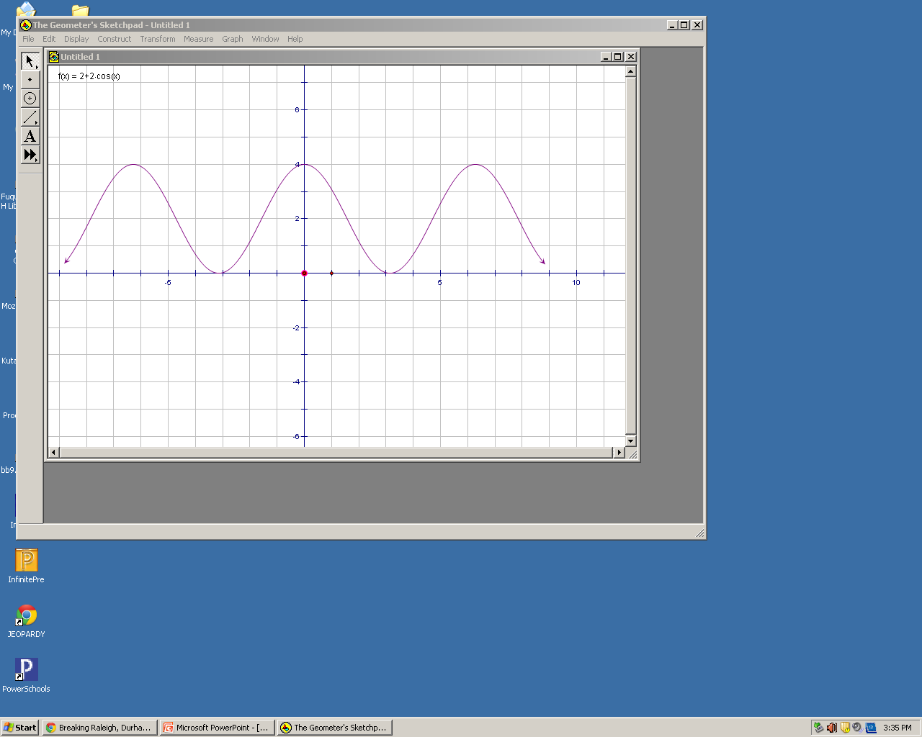First sketch the graph to find what interval makes a full curve either by hand or on the calculator.

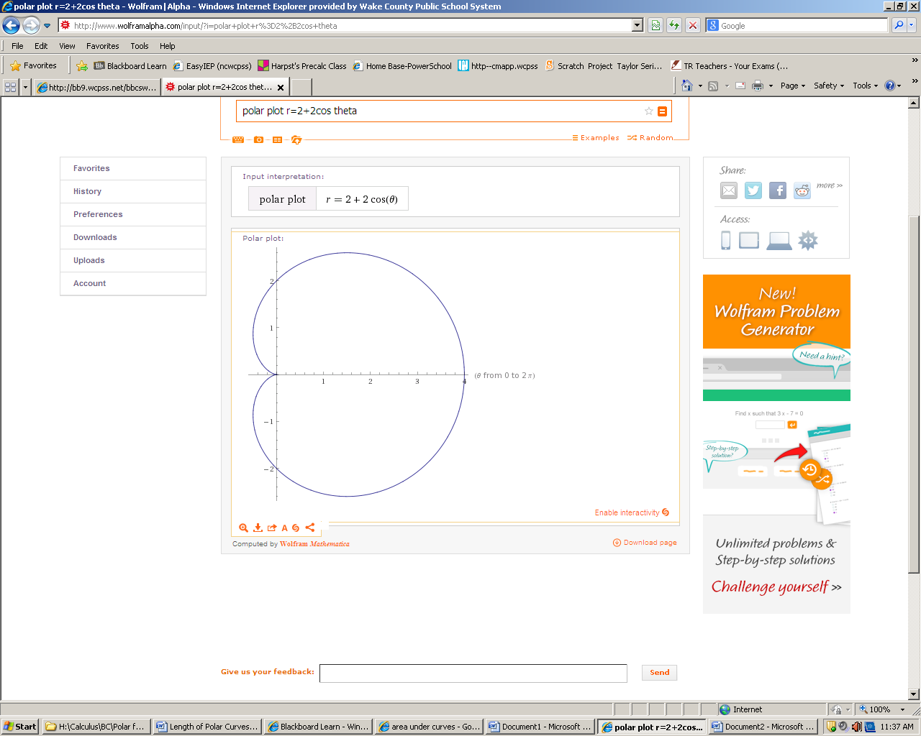

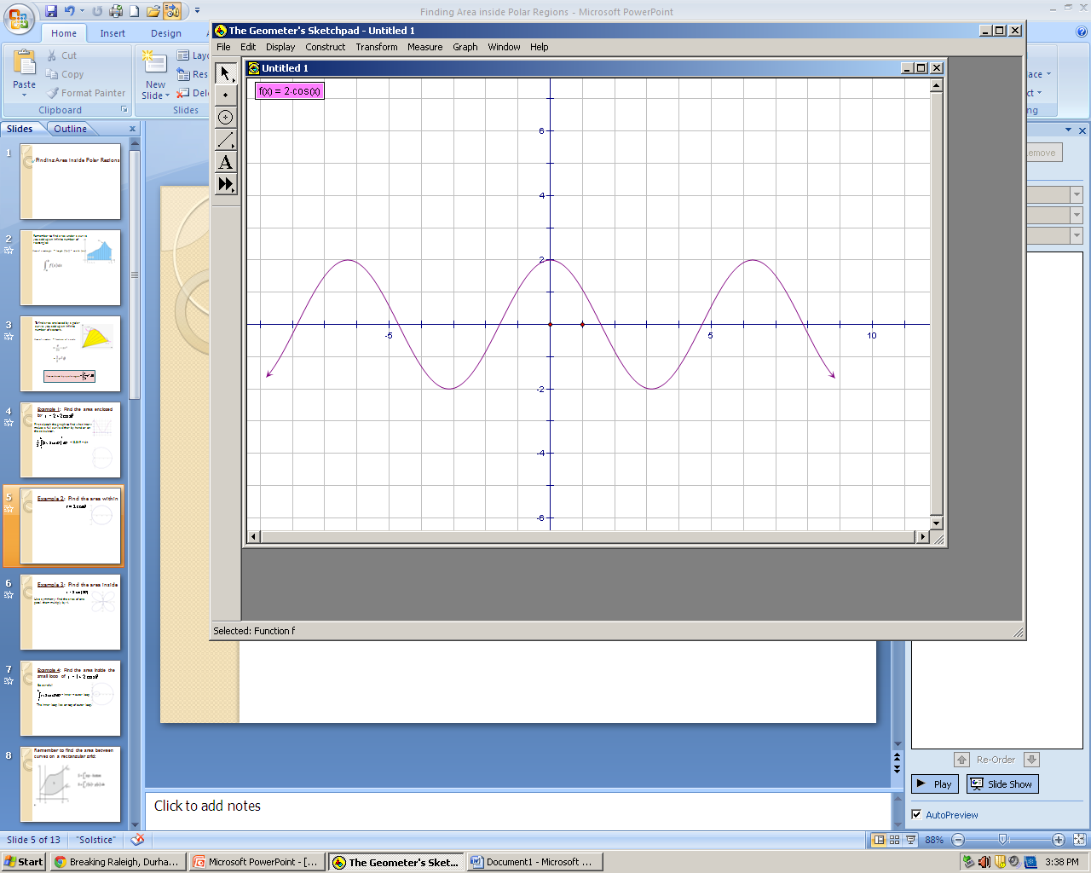Example 2: Find the area inside $r=2\cos{θ}$.

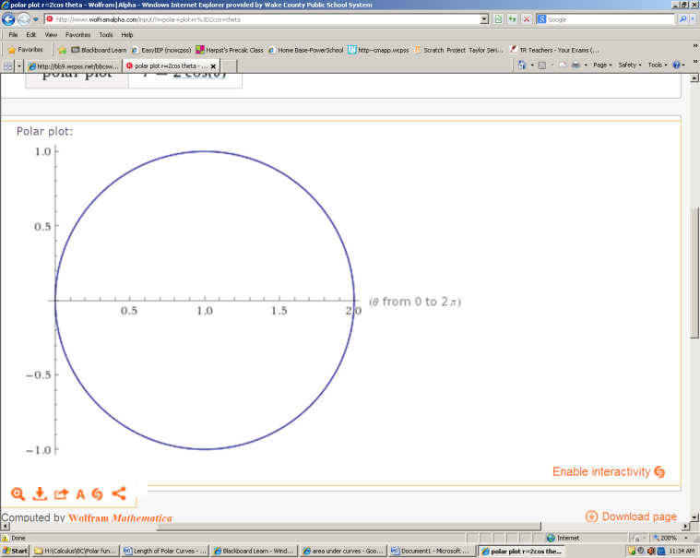

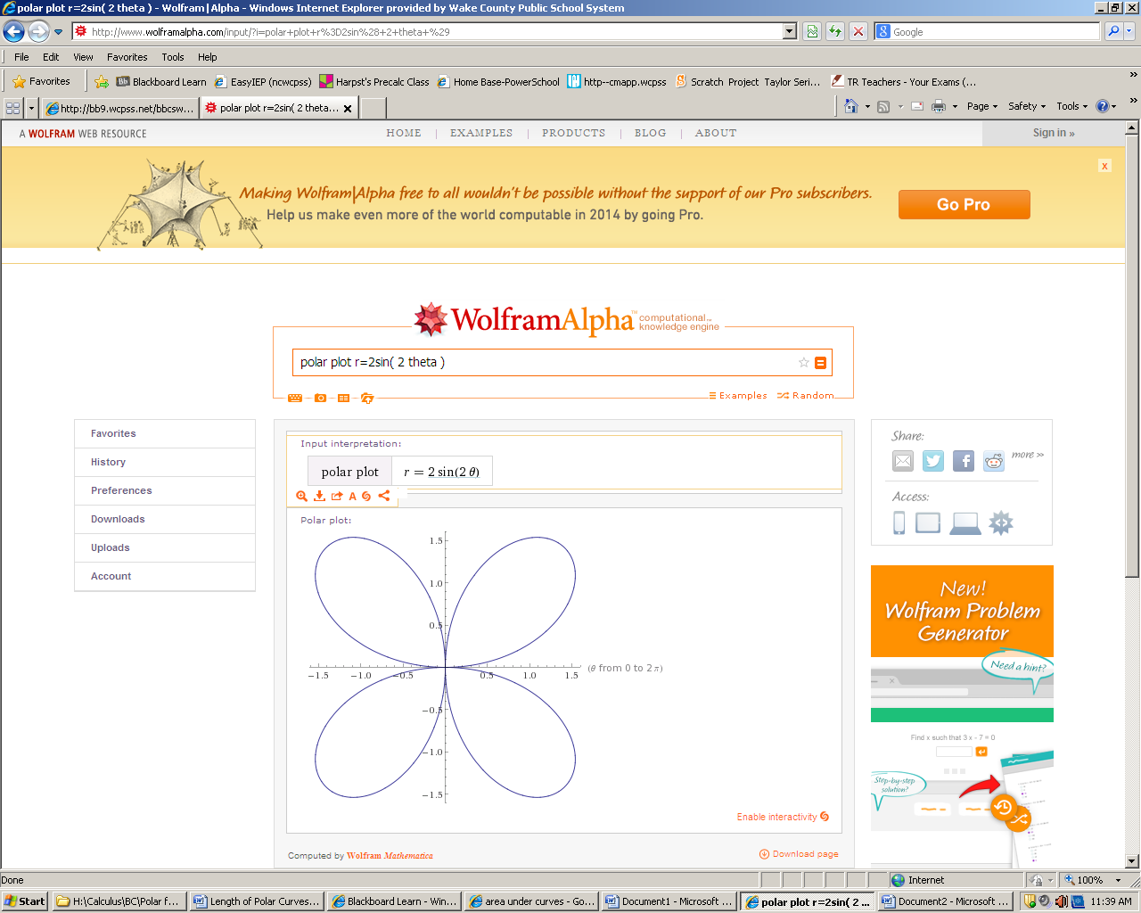

Example 3: Find the area inside $r=2\sin\left(2θ\right)$

Use symmetry; find the area of one petal, them multiply by 4.

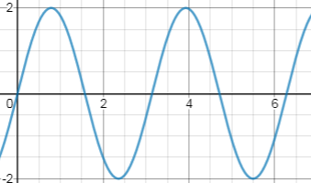

Example 4: Find the area inside the small loop of $r=2-4\cos{θ}$

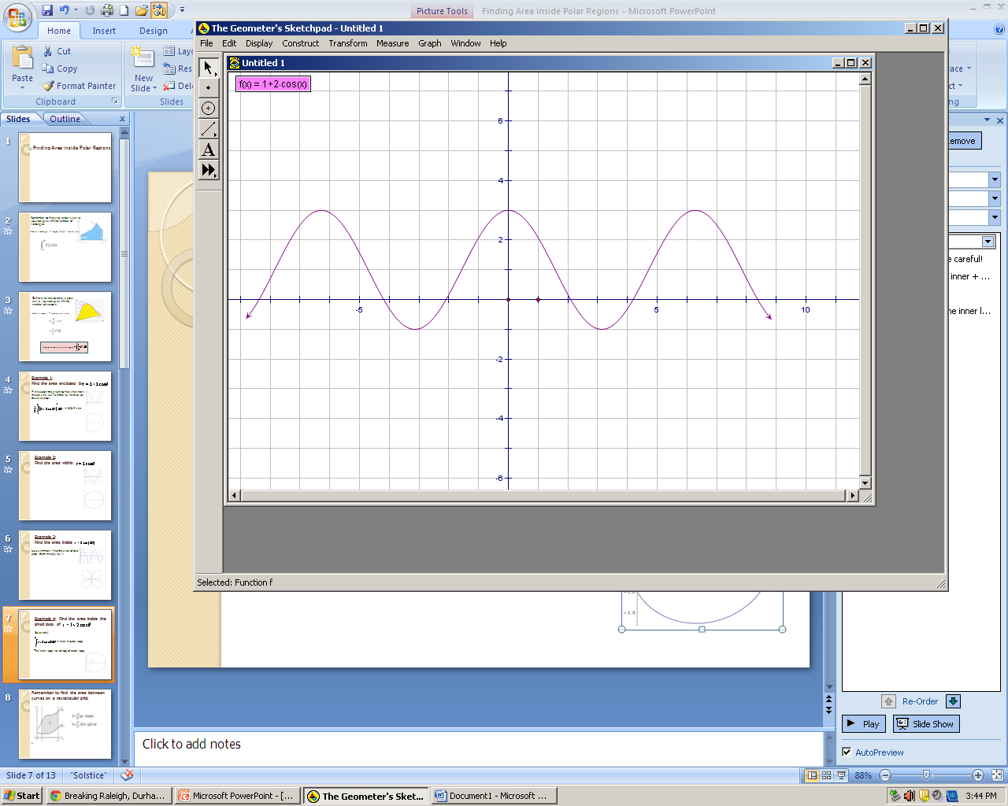

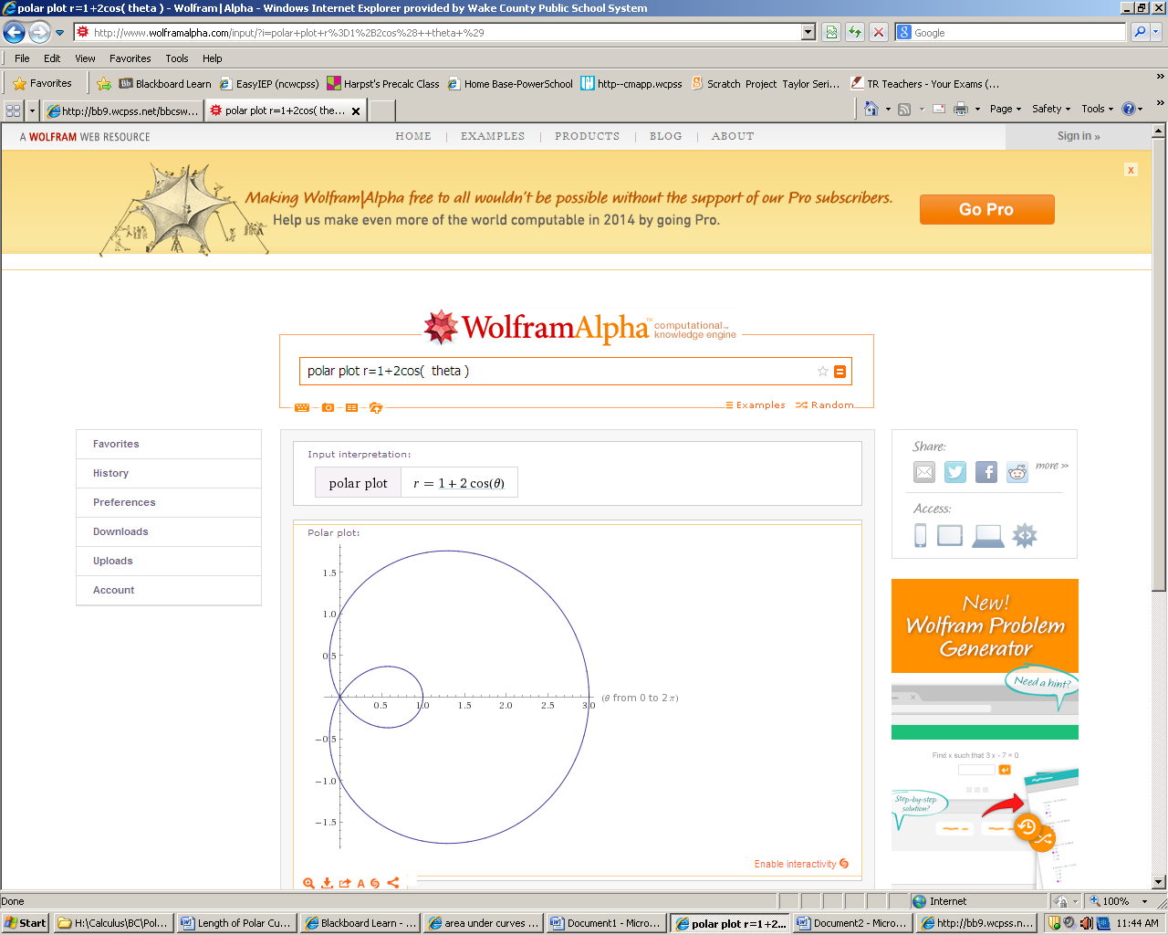

Homework: Sec 9.5 p.676 #1-17 odd

Remember to find the area between curves

on a rectangular grid:

Example 5: Find the area inside $r=3+2\sin{θ}$, but outside $r=2$.

As with areas between Cartesian curves, find the intersection of the curves.

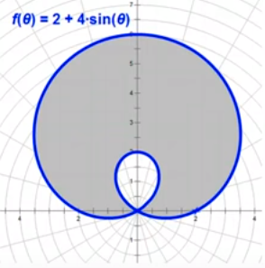Example 6: Find the area between the loops of $r=2+4\sin{θ}$

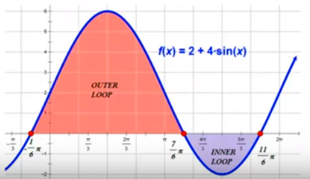

Be careful! $\int_{0}^{2π}{2-4\cos{θ} dθ}$ = inner + outer loop . The inner loop lays on top of outer loop.

Example 7:

Find the area enclosed by $r=\sin{θ}$ and $=\cos{θ}$.

This is a piecewise area problem!

Try:

1. Find the area of the region inside $r=1$ and outside .

2. Find the area of the region inside $r=-6\cos{θ}$ and $r=2-2\cos{θ}$

Homework: Sec 9.5 p.676 #12, 14, 19 – 25odd, 37 - 45 odd, 77, 78