Find the limit.
1.$\lim_{h→0}{\frac{{\left(2+h\right)}^{2}-8}{h}}$ 2. $\lim_{x→9}{\frac{2\sqrt{x}-6}{x-9}}$
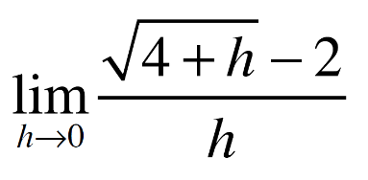
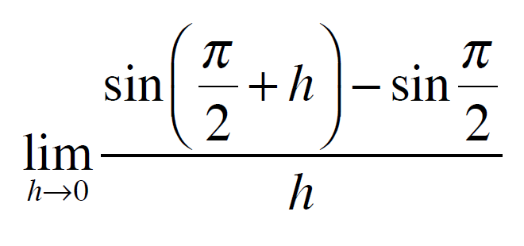
3. 4.

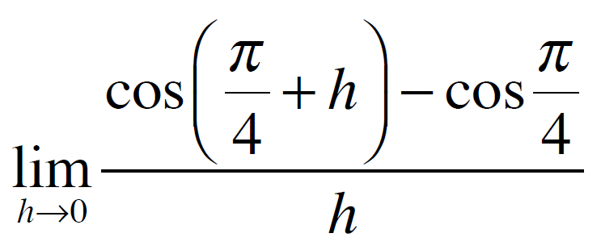
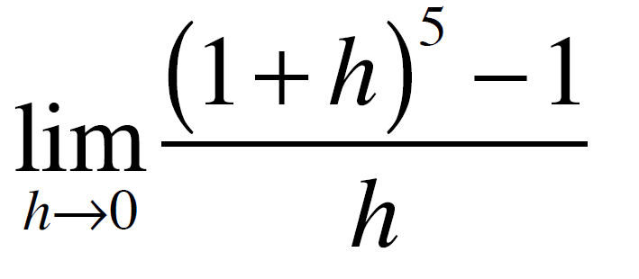
5. 6.

Tricky Limits that are really Derivatives
Find the limit.
1.$\lim_{h→0}{\frac{{\left(2+h\right)}^{2}-8}{h}}$ 2. $\lim_{x→9}{\frac{2\sqrt{x}-6}{x-9}}$
3. 4.

5. 6.

