Pre-Calculus Review

What is a function?

* Graphically
* Algebraically
* Numerically
* Verbally

Examples of relations that are and are not functions

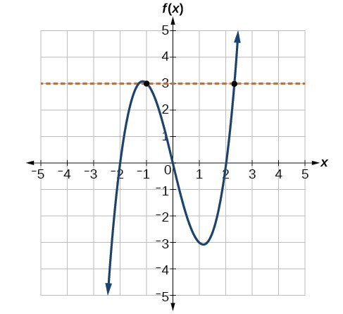Evaluate a function using g(x) = 4x +2: g(6) = g(-2) =

f(-2) = f(1) =

Independent vs. Dependent Variables:

**Types of Functions**

1. **Polynomial functions** (subset: **power functions** which have only one term)

* **Linear** : Basic power function: Slope (def., formula)

Domain:

Range: slope of Parallel lines are

slope of Perpendicular (Normal) lines are

**Forms of linear equations:**

Slope intercept form Standard form Point-Slope form

* **Quadratic**: Basic power function: Similarly shaped functions:

Domain:

Range:

Even or Odd? Why? Algebraically:

Graphically:

**\*\*\*\*Graphs have symmetry. Functions are even, odd or neither. \*\*\*\***

On what interval is the quadratic function increasing?

Decreasing?

**\*\*\*\* Interval notation: ( means not included, [means included, never include infinity\*\*\*\***

* **Cubic**: Basic power function: Similarly shaped functions:

Domain:

Range:

Even or Odd? Why? Algebraically:

Graphically:

On what interval is the function increasing? Decreasing?

**Determining Symmetry**

* Polynomial functions with all even degrees are even
* Polynomial functions with all odd degrees are odd
* Polynomial functions with mixed odd/even degrees are neither
* Constants are of even degrees
* Any function that is more complicated, do f(-x) test

Examples: do the f(-x) test on the following:

$f\left(x\right)=x^{4}+x^{2}$ $f\left(x\right)=x^{3}+x^{2}$

* **Radical** : Basic power function: Domain:

Range:

**\*\*\*Can only take even roots of non-negative numbers (zero or positive). \*\*\***

**Similarly shaped Functions**

$f\left(x\right)=x^{a/b}$

If b is even, graph Does Not Exist when x <0.

If b is odd, and a is even, graph has even symmetry.

If b is odd, and a is odd, graph has odd symmetry.

**Generalizing: $f\left(x\right)=kx^{a}$**

I II

a < 1 0 < a < 1 a = 1 a > 1

III

IV

2. **Rational Functions**: ratio of 2 polynomial functions $f\left(x\right)=\frac{g\left(x\right)}{h\left(x\right)}$

**\*\*\*Denominators cannot equal zero\*\*\***

Basic function: **Reciprocal function**: $y=\frac{1}{x}$

Domain:

Range:

Horizontal asymptote: Vertical asymptote:

**\*\*\*Asymptotes are lines represented by equations, not a lone number. \*\*\***

* Vertical asymptotes describe where the y - values are approaching positive or negative infinity from the left or the right.
* Factors that cancel out indicate holes; factors that remain in the denominator indicate vertical asymptotes.

Example: $f\left(x\right)=\frac{x-1}{x^{2}-4x+3}$ =

Hole at

Vertical asymptote:

Domain:

* Horizontal asymptotes describe end behavior, what the y-values are approaching as x approaches positive or negative infinity.
* Graphs **can** cross a horizontal asymptote.
* For rational functions, compare the degrees of the numerator and denominator.

“BOSTON”

B*ottom degree is larger*

O *(zero) is the location of the horizontal asymptote*

S*ame degrees*

T*ake the coefficients as the asymptote*

O*therwise*

N*o horizontal asymptote*

Example continued from above: $f\left(x\right)=\frac{x-1}{x^{2}-4x+3}$ example: $f\left(x\right)=\frac{5x^{4}-3}{3x^{4}+2x}$

Horizontal asymptote: Horizontal asymptote:

Range: Vertical asymptote:

3. Absolute value Function Basic Equation:

Domain: Range:

Even or Odd?

$\left|4\right|=$

$\left|-4\right|=$ $\left|a\right|=\left\{\begin{aligned} \\ \\ \end{aligned}\right.$

Absolute value functions can be written as a piecewise function:

$y=\left|x\right|=\left\{\begin{aligned} \\ \\ \end{aligned}\right.$ $y=\left|2x-5\right|=\left\{\begin{aligned} \\ \\ \end{aligned}\right.$

Examples:

Write a piecewise function for the graph. Graph $f\left(x\right)=\left\{\begin{aligned}1-x, if x≤1 \\ x^{2}, if x>1\end{aligned}\right.$

 Domain: Domain:

 Range: Range:

Y =