Section 9.10 Taylor and MacLaurin Series

We found power series representations when

functions or their integral or derivatives were

of the form $\frac{a}{1-r}$. Today, our goal is the same,

but our method is different.

All functions, including some important functions like f(x) = cos x, can be approximated using a polynomial. The polynomial itself will not be exactly the same value of the function, but can at times be so close that there really isn’t much difference in the values of f(x) at certain values of x.

Consider $f\left(x\right)=\cos{x=c_{0}}{+c}_{1}x+c_{2}x^{2}+c_{3}x^{3}+c_{4}x^{4}+…+c_{n}x^{n}+…$

$$f\left(x\right)=\cos{x=}$$

$f\left(x\right)=\cos{x=}\sum_{n=0}^{∞}{\frac{{\left(-1\right)}^{n}x^{2n}}{\left(2n\right)!}}$ What is the interval of convergence?

Definitions of Taylor and Maclaurin SeriesIf a function *f* has derivatives of all orders at x = a, then the series



  
   
is called the **Taylor series for f(x) centered at a.** If the center of the function is at zero, c = 0, then the series is called a **Maclaurin series for *f*.**



Maclaurin is just a special form of the Taylor series.  
Taylor and Maclaurin series have an infinite number of terms. A **Taylor** or **Maclaurin polynomial** will have a finite number of terms.

Example:

Find the Taylor Series of the function $f\left(x\right)=e^{x}$ and its radius of convergence centered at x = 0.

Example:

Find the Taylor Series of the function $f\left(x\right)=\ln{x}$ and its radius of convergence centered at x = 1.

Important Maclaurin Series you need to memorize!!!

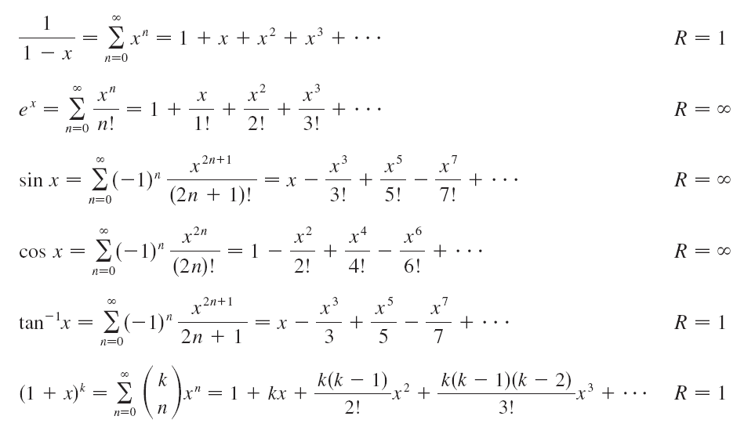

Use these series to create other series.

Example:

Find the Taylor Series of the function $f\left(x\right)=\frac{e^{2x}}{x^{3}}$ and its radius of convergence centered at x = 0.

******If the series is not centered at zero, you must derive the series!******

Example:

Given: $f\left(x\right)=1-3x^{2}+5x^{4}+8x^{6}+…$. Is there a relative max. min, or neither at f(0)?

Example:

Given: $f\left(x\right)=1+2x-3x^{2}+6x^{4}+7x^{5}+…$. Is there a relative max. min, or neither at f(0)?

Is f(x) increasing or decreasing at x = 0?

Is f(x) concave up or concave down at x = 0?