Section 9.9 Representing Functions by Power Series

 , $\left|x\right|<1$ We know this is a geometric series with a = and r =

The sum of a geometric series is $\frac{a}{1-r}$. So the sum would be

Find the equivalent function and the interval of convergence



Practice Problems

1. 
2. 
3. 

The function and the series behave the same on the interval of convergence. Each partial sum is an approximation of f(x). The more terms, the better the approximation.

Now go in the opposite direction,

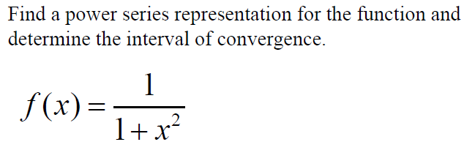Example 1.

Example2: Write $f\left(x\right)=\frac{1}{2+x}$ as a power series

Remember a power series is $\sum_{n=0}^{∞}{C_{n}x^{n}}$ so you must do the following:

* Separate the coefficient part from the variable
* Combine common bases into a single exponential expression
* Pull out (-1) if it’s an alternating series
* Adjust exponent on (-1) to n, n – 1 , or n + 1

Example 3: Write $f\left(x\right)=\frac{x^{3}}{2+x}$ as a power series

Another way to look at Example 3

Adjusting the exponent on x

 Do the same thing to all exponents.

Do the opposite to the starting n value

Readjust (-1) exponent to n, n – 1 , or n + 1

You Try:



Are the Series Equivalent?

  Expand to find out.

 

Writing Series in Expanded form: 







Practice





