C:\Documents and Settings\jmackey\Local Settings\Temporary Internet Files\Content.IE5\GTZSSUR0\MC900111366[1].wmf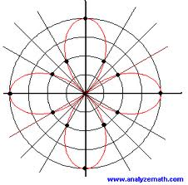BC Unit 4 Polar

Functions

|  |  |  |
| --- | --- | --- |
|  | Topic | Assignments |
| Day 1  Wed 3/1 | Finish Test  Review of Polar Coordinates | Calculaugh 10  Unit circle review Worksheet |
| Day 2  Thurs 3/2 | Unit circle Quiz  Converting between rectangular and polar functions | p.683 #1-15odd,17,21,25,29,  33-43 odd |
| Day 3  Fri 3/3 | Graphing Polar Functions | p.689 #23,27,31,35,39  sketch graph only |
| Day 4  Mon 3/6 | Derivatives of Polar Functions | p.689 #7-15 find equation of tangent line, 17,19 |
| Day 5  Tues 3/7 | Quiz  Finding Tangents at the pole | #23,27,31,35,39,53 find tangent at the pole |
| Day 6  Wed 3/8 | Arc length  Area | p.697 #13-19 odd, #33-37 |
| Day 7  Thurs 3/9 | Area between Curves | p.697 #14-20 even, 21-29 odd |
| Day 8  Fri 3/10 | Review | Review worksheet |
| Day 9  Mon 3/13polar cartoon.bmp | Test | Problem Set |