Name ____________________________ Unit 5 – AP Classroom Free Response

Please remember to complete the 8 multiple choice questions on AP Classroom along with this free response question.
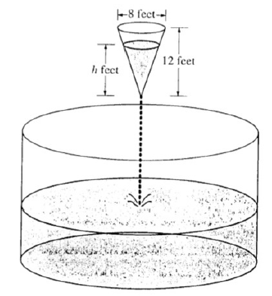

As shown in the figure above, water is draining from a conical tank with height 12 feet and diameter 8 feet into a cylindrical tank that has a base with area $400π$ square feet. The depth h, in feet, of the water in the conical tank is changing at the rate of $(h-12)$ feet per minute. (The volume V of a cone with radius r and height h is $V=\frac{1}{3}πr^{2}h$)
- Write an expression for the volume of water in a conical tank as a function of h.

- At what rate is the volume of water in the conical tank changing when $h=3$? Indicate units of measure.

- Let $y$ be the depth, in feet, of the water in the cylindrical tank. At what rate is $y$ changing when $h=3$? Indicate units of measure.

