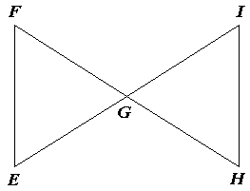**Write a flow proof for the following :**

**1:**  ***Given:*** *G* is the midpoint of 

and G is the midpoint of .

***Prove:*** 

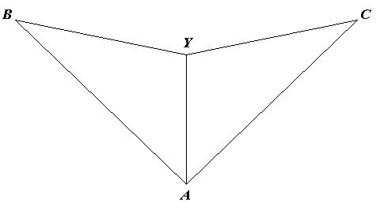

**2:**  ***Given: *** and 

***Prove:*** 

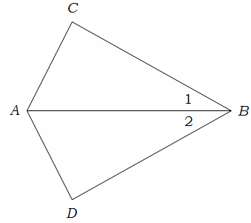**3:**

***Given:***  bisects 



***Prove:*** 

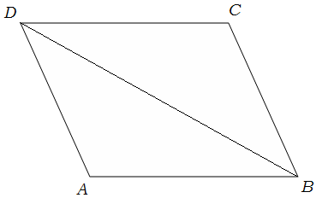**4:**

***Given:*** ⎟ ⎢



***Prove: ***