Name ________________________________ BC Differential Equations FRQ

- Liquid fertilizer is injected into a hydroponics growing system via a pumping system. The total amount of liquid fertilizer injected into the growing system by time t is modeled by the function F that satisfies the logistic differential equation $\frac{dF}{dt}=\frac{1}{3}F(6-F)$, where t is measured in months and F is measured in liters. At time $t=0,$ 3 liters of liquid fertilizer are injected into the growing system. (Note: Hydroponics is the process of growing plants in sand, gravel, or liquid, with added nutrients but without soil.)

- Find $\lim_{t→∞}{F(t)}$ b) Find $\lim_{t→∞}{\frac{dF}{dt}}$ c) Find $\lim_{t→0}{\frac{F\left(t\right)-3}{t}}$

- Consider the differential equation $\frac{dy}{dx}=2x-y$
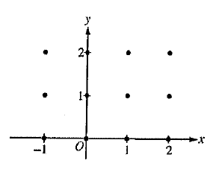
- On the axes provided, sketch a slope field for the given differential equation at the twelve points indicated, and sketch the solution curve that passes through the point $(0,1)$.

- The solution curve that passes through the point $(0,1)$ has a local minimum at $x=\ln\left(\frac{3}{2}\right)$. What is the y-coordinate of this local minimum?

- Let $y=f(x)$ be the particular solution to the given differential equation with the initial condition $f\left(0\right)=1$. Use Euler’s method, starting at $x=0$ with two steps of equal size, to approximate $f(-0.4)$. Show the work that leads to your answer.

- Find $\frac{d^{2}y}{dx^{2}}$ in terms of x and y. Determine whether the approximation found in part (c) is less than or greater than $f\left(-0.4\right).$ Explain your reasoning.

