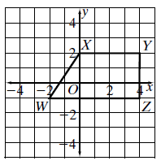**Foundations of Math 2 Name: ______________________ Unit 1 Day 7 – Dilations Homework**

1. Find the coordinates and graph the image of

quadrilateral *WXYZ* after a dilation about the origin

with a scale factor of .

Identify your coordinates for *W’, X’, Y’, Z’*

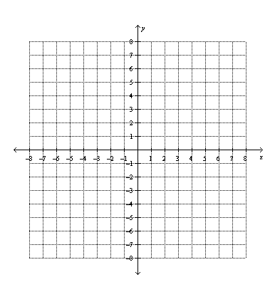

1. A triangle has coordinates *A*(-2, -2), *B*(4, -2),

and *C*(1, 1). Graph its image *A’B’C’* after a

dilation with scale factor .

Give the coordinates of *A’B’C’*.

**3.** The coordinates of ABC are A(2, -1), B(3, 2) and C(-3, 1). Dilate the triangle about the origin by a scale factor of three.

Vertices: Algebraic Rule:

4. The coordinates of ABC are A(2, -1), B(3, 2) and C(-3, 1). The coordinates of A’B’C’ are

A’(4, -2), B’(6, 4), and C’(-6, 2).

Transformation: Algebraic Rule: