Factorials!

n! =

**Examples:**

4! = 6! =

n!= (n – 2)! =

(n + 1)!= 0! = Why?

$\frac{5!}{7!}=$ $\frac{8!}{11!}=$ $\frac{59!}{57!}=$

$\frac{(n-2)!}{n!}=$ $\frac{(2n-1)!}{(2n+1)!}=$

**Practice**





**Section 8.1 Sequences**

A **sequence** is a list or set whose domain is a set of positive integers.

{a1, a2, . . . } where

**Examples:** Find the first three terms of each sequence

$$a_{n}=\frac{n}{n^{2}+1}$$

$$a_{n}=\frac{n^{2}}{2^{n}-1}$$

$$a_{n}=\frac{2^{n}}{n!}$$

$$a_{n}=3+{\left(-1\right)}^{n}$$

A sequence is increasing if $a_{n+1}>a_{n}∀ \left(for all\right) n≥1$

A sequence is decreasing if $a_{n+1}>a_{n}∀ n≥1$

A **monotonic sequence** is always increasing or always decreasing (not oscillating)

A sequence can be bounded above if $a_{n}<U$ or bounded below if $a_{n}>L ∀ n≥1$

**Convergence vs. Divergence of a Sequence**

If $\lim_{n→∞}{a_{n}=L}$, the sequence converges to L. That means, eventually, the terms become L.

Otherwise the sequence diverges.

A divergence sequence may approach $±∞$ or may be oscillating between two numbers.

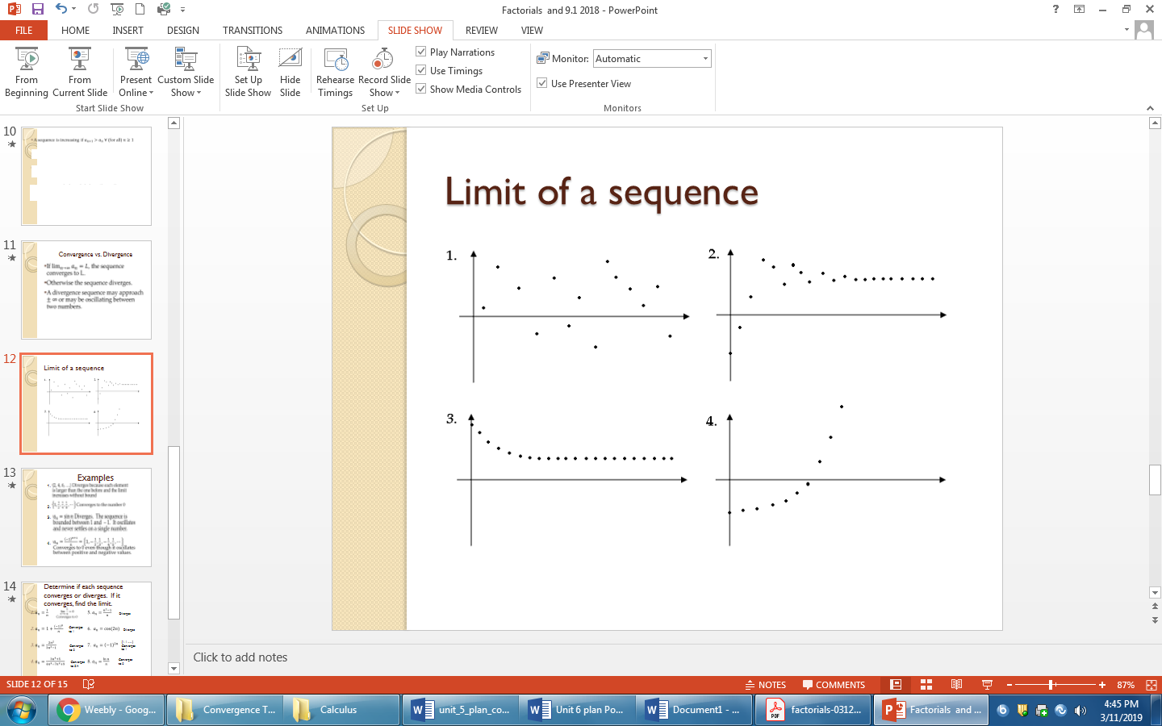

**Examples**

1. {2, 4, 6, . . . .}

$\{1,\frac{1}{2},\frac{1}{4},\frac{1}{8},. . . \}$

$a_{n}=\sin{n}$

$a_{n}=\frac{{\left(-1\right)}^{n+1}}{n}$

**Practice:**

Determine if each sequence converges or diverges. If it converges, find the limit.

