[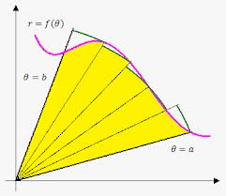](http://www.google.com/imgres?sa=X&rls=com.microsoft%3Aen-us%3AIE-SearchBox&biw=1280&bih=843&tbm=isch&tbnid=bYHGk7ePiMSVWM%3A&imgrefurl=http%3A%2F%2Fwww.emathhelp.net%2Fnotes%2Fcalculus-2%2Fapplications-of-integrals%2Farea-in-polar-coordinates%2F&docid=Hv-GQsCEaAAxOM&imgurl=http%3A%2F%2Fwww.emathhelp.net%2Fimages%2Fcalc%2F6_1_polar_area.png&w=349&h=303&ei=spAYU7vZO47JkAerrIEo&zoom=1&iact=rc&dur=640&page=1&start=0&ndsp=21&ved=0CIoBEK0DMBI)Finding area inside polar regions

Remember to find area under a curve you add up an infinite number of rectangles

[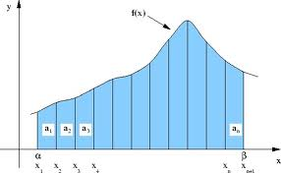](http://www.google.com/imgres?sa=X&rls=com.microsoft%3Aen-us%3AIE-SearchBox&biw=1280&bih=843&tbm=isch&tbnid=hmEI7QxxW8_YMM%3A&imgrefurl=http%3A%2F%2Fwww.pleacher.com%2Fhandley%2Flessons%2Fcalc2004%2Fday93.html&docid=Ua1469UXeVOEAM&imgurl=http%3A%2F%2Fwww.pleacher.com%2Fhandley%2Fgifs4%2Farea1.jpg&w=552&h=340&ei=KZEYU5eSNou2kQeRtYDwAw&zoom=1&iact=rc&dur=2672&page=1&start=0&ndsp=20&ved=0CI0BEK0DMBM)Area of a rectangle = length (f(x)) * width (dx)

$$\int_{a}^{b}{f\left(x\right)dx}$$

To find area enclosed by a polar curve, you add up an infinite number of sectors.

Area of a sector = fraction of a circle

$=\frac{θ}{2π}*πr^{2}$

= $\frac{1}{2}r^{2}θ$

Area enclosed by a polar region $=\int_{a}^{b}{\frac{1}{2}r^{2}dθ}$

Example 1: Find the area enclosed by $r=2+2\cos{θ}$

First sketch the graph to find what interval makes a full curve either by hand or on the calculator.

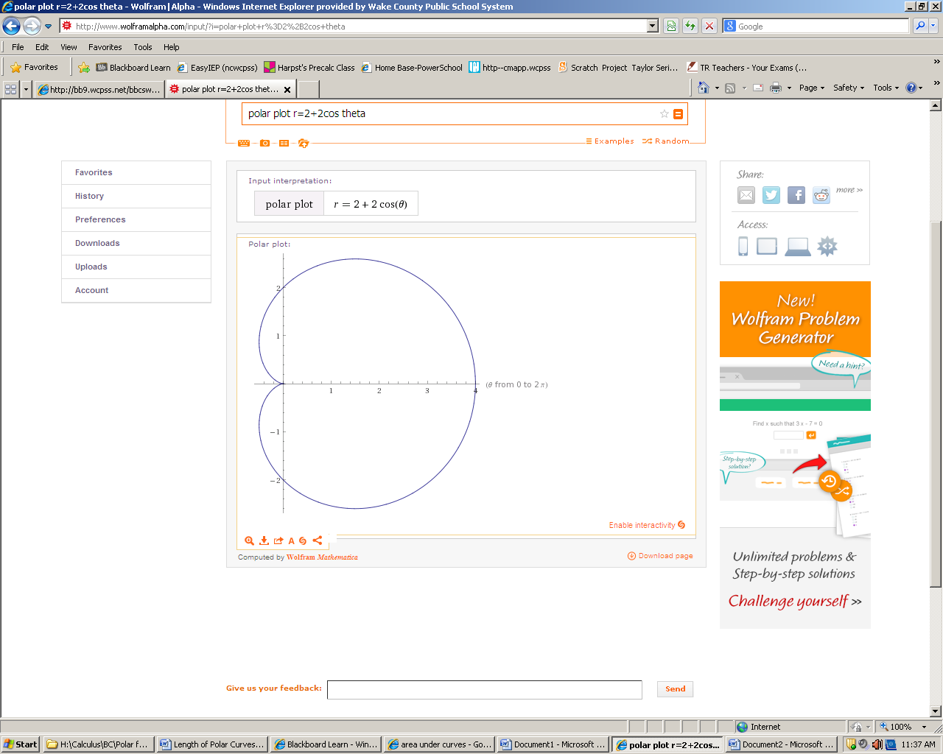

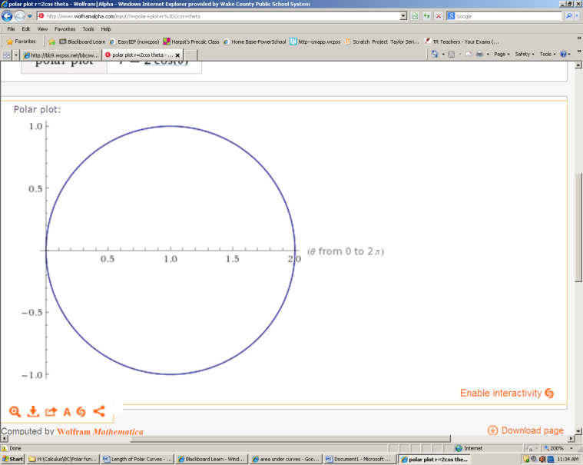Example 2: Find the area within $r=2\cos{θ}$.

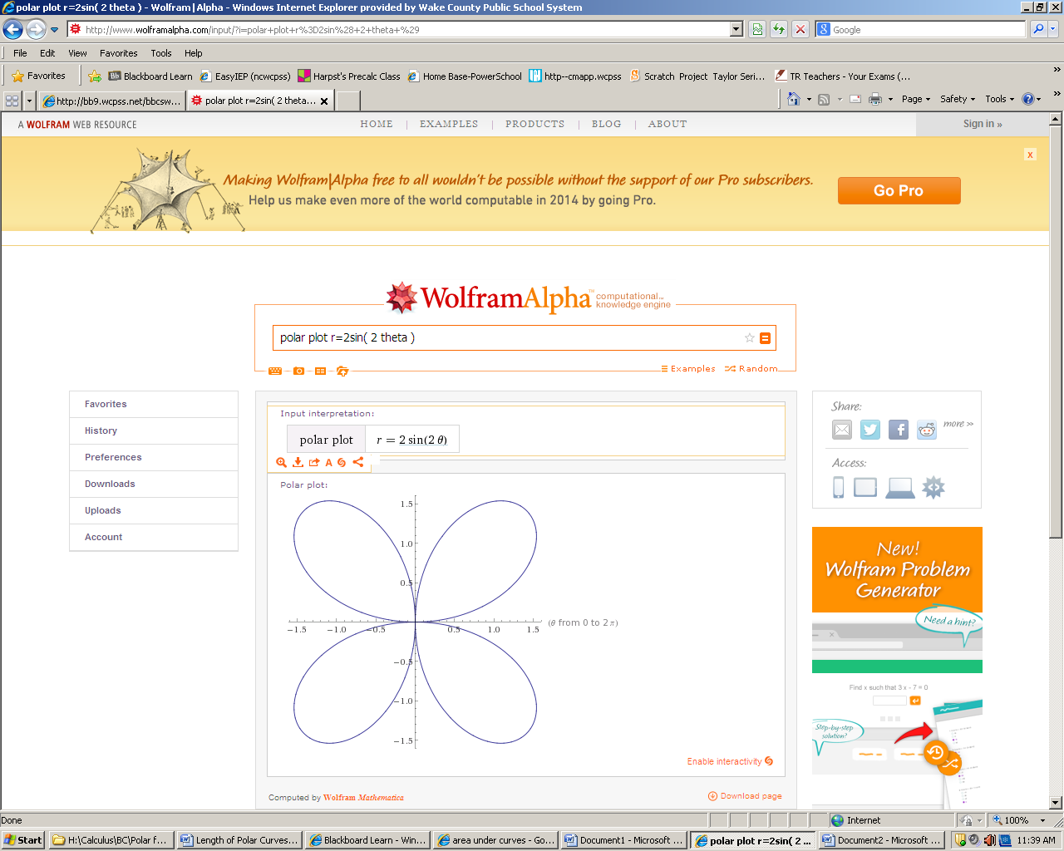

Example 3: Find the area inside $2\sin\left(2θ\right)$

Use symmetry; find the area of one petal, them multiply by 4.

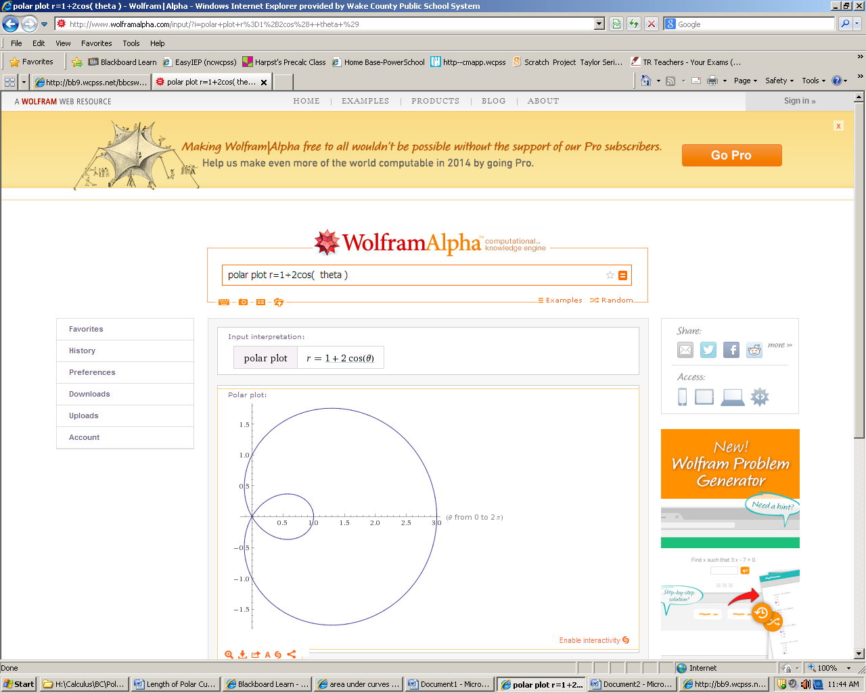Example 4: Find the area inside the small loop of $r=1+2\cos{θ}$

Be careful! $\int_{0}^{2π}{1+2\cos{θ} dθ}$ = inner + outer loop . The inner loop lays on top of outer loop.

Remember to find the area between curves on a rectangular grid:

To find the area between curves on the polar grid:



Example 5: Find the area inside $r=3+2\sin{θ}$, but outside $r=2$.

Just like finding areas between Cartesian curves, the limits of integration are the intersection of the curves.

Example 6:

Find the area enclosed by $r=\sin{θ}$ and $=\cos{θ}$.

This is a piecewise area problem!

Try:

1. Find the area of the region inside $r=1$ and outside .

2. Find the area of the region inside $r=-6\cos{θ}$ and $r=2-2\cos{θ}$

Homework: p. 697 #13 -29