Graphs of functions and their derivatives
Example:
A function f is continuous on the interval [-4, 3] with the following properties.
Intervals | -4 < x < -2 | X = -2 | -2 < x < 1 | X = 1 | 1 < x < 3
f’ | -- | 0 | -- | DNE | +
f’’ | + | 0 | -- | DNE | --

- Find the x-coordinates of all relative extrema on the domain [-4, 3]. Classify
them as relative max or relative mins. Justify your answer.

- Find the x-coordinates of any point of inflection on the domain [-4, 3]. Justify your answer.

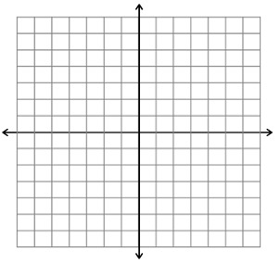
- Sketch a possible graph of f(x), given that f(-4) = 6 and f(3) = 2.

