There are times when we need to describe motion (or a curve) that is not a function.
We can do this by writing equations for the x and y coordinates in terms of a third
variable (usually time or $θ$ ).
Each parametric equation gives one of the coordinates of position at a certain time.
$x=f\left(t\right) y=g(t)$
Parametric Equations can be used to answer questions of where and when.
Example: Write a set of parametric equations for the line $y=\frac{1}{2}x+3$
One possible answer: Another answer:
A: B:

Graphs look the same, but parametric equations show location at a certain time.
When t = 4, Graph A is at ( ) and Graph B is at ( )
Both are traveling along the same line, just B is traveling faster.

Example: $x=\sqrt{t} , y=t+1$
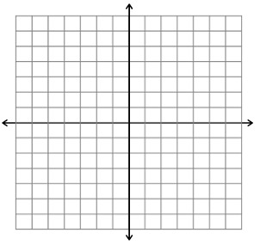
Make a table of values and sketch the curve, indicating the direction of the curve. Then eliminate the parameter.
t | X | y

Example: Graph the plane curve represented by the parametric equations:
$$x=3+2\cos{t}, y=-1+3\sin{t }; 0≤t≤2π$$
t | x | y

Now eliminate the parameter.

Derivatives

$\frac{dy}{dt}=$ $\frac{dx}{dt}=$

$$\frac{dy}{dx}=$$

Given $\left\{\begin{aligned}x=4\sin{t} \\ y=2\cos{t}\end{aligned}\right.$ Find dx/dt, dy/dt, and dy/dx at t = $π/4$

Example: Describe the movement and write an equation of the tangent line when t = 1

Example: Find all the points of vertical and horizontal tangency.

Second Derivatives
Example: $x=\sin{t}$ Find dy/dx
$y=t^{2}+1$

To find the second derivative of a parametrized curve, we find the derivative of the first derivative:
$$\frac{d^{2}y}{dx^{2}}=\frac{d}{dx}\left(y^{'}\right)=$$

Example:

Example:
Given the parametric equations $\left\{\begin{aligned}x=\sqrt{t} \\ y=\frac{1}{4}t^{2}-1\end{aligned}\right.$ Find the slope and concavity at (2, 3)

Arc Length of a Parametric Equation

Find the length of

