**Unit 1 Day 4 Practice: Reflections Name: ___________________________**

**Graph the image using the transformation given, and give the algebraic rule as requested**

|  |  |
| --- | --- |
| 1. ΔEFG if E(-1, 2), F(2, 4) and G(2, -4) reflected over the y-axis.   E’ _____  F’ _____  G’ _____    Rule: | 1. ΔPQR if P(-3, 4), Q(4, 4) and R(2, -3) reflected over the x-axis.   P’ _____  Q’ _____  R’ _____    Rule: |
| 1. Quadrilateral VWXY if V(0, -1), W(1, 1), X(4, -1), and Y(1, -5) reflected over the line y = x.   **V’ _____**  **W’ _____**  **X’ _____**  **Y’ ______**  Rule: | 1. ΔBEL if B(-2, 3), E(2, 4), and L(3, 1) reflected over the line .   B’ _____  E’ _____  L’ _____  Rule: |
| 1. Square SQUR if S(1, 2), Q(2, 0), U(0, -1), and R(-1, 1) reflected over the line .   S’ _____  Q’ _____  U’ _____  R’ _____ | 1. Quadrilateral MATH if M(1, 4), A(-1, 2), T(2, 0) and H(4, 0) reflected over .     M’ _____  A’ _____  T’ _____  H’ _____ |

Write a specific description of each transformation and give the algebraic rule, as requested.

7. 8.

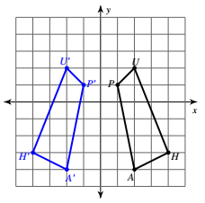 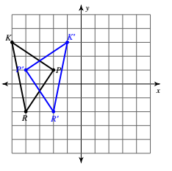

Algebraic Rule:

Description:

Description:

Find the image of the following transformations and give a specific description.   
*Hint:* If you get stuck, review the Checkpoints after today’s activities. ☺

9. The points (2,4), (3,1), (5,2) are reflected with the rule   
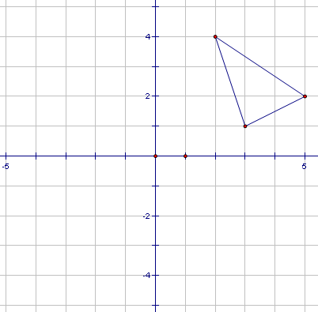

Description:

Vertices of Reflection:

10. The points (2,4), (3,1), (5,2) are reflected with the rule 



Vertices of Reflection:

Description:

Notation: