7. m∠ Z = m∠ V= m∠ H = m∠ P =

ΔXYZ ~ΔHPV

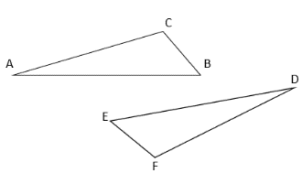Determine if the given information proves the triangles are congruent. State which reason justifies your decision.

8. Given: ≅ ∠B ≅ ∠E, ∠C ≅ ∠F

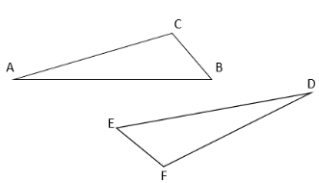

9. Given: ≅



10. Given: ≅ , ∠D ≅ ∠A



11. Given: ∠C and ∠F are right angles, ≅



12. Given: ∠B ≅ ∠E, ∠C ≅ ∠F, ∠D ≅ ∠A



13. Given: , ≅ ∠F ≅ ∠C

14. Given: ∠C ≅ ∠F, ∠D ≅ ∠A, $\overline{BC} \overline{EF}$

What additional information do you need to prove the triangles congruent by the given reason?

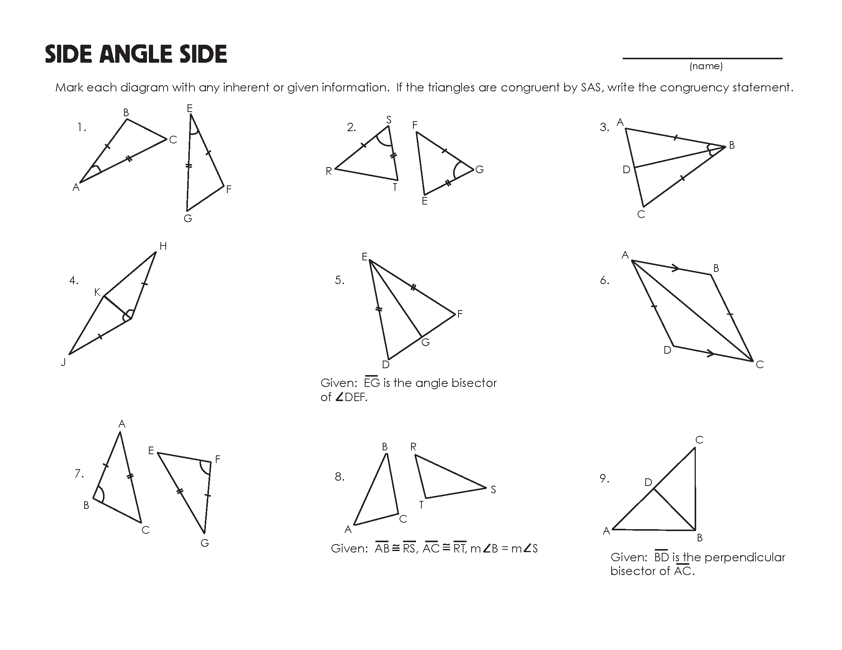15. by AAS if ∠C ≅ ∠T, ∠R ≅ ∠A 16. by SAS if $\overline{RS} \overline{AB}$, $\overline{AC}$ ≅ $\overline{RT}$

Given $∆BCA≅∆ECD$, complete the statements.

17. ∠D ≅ _________ 18. __________ 19. ΔCDE ≅ ________________

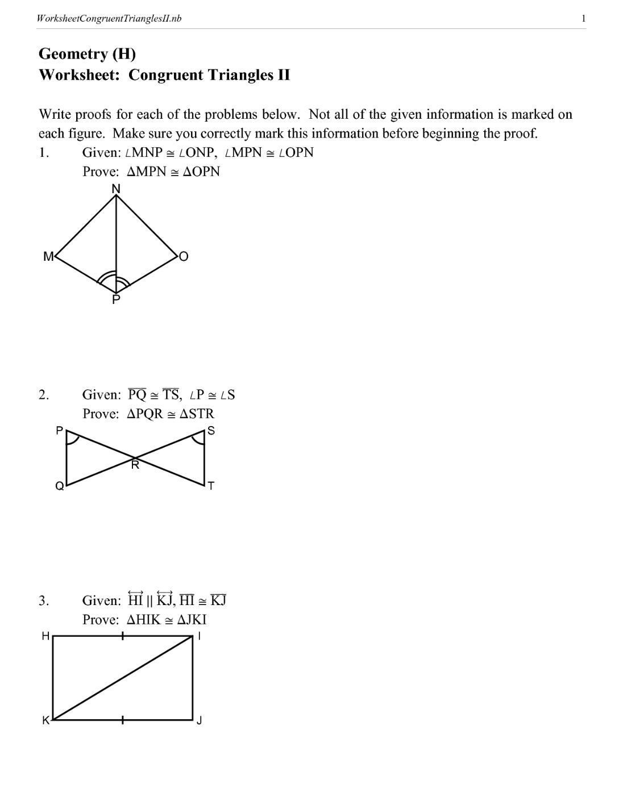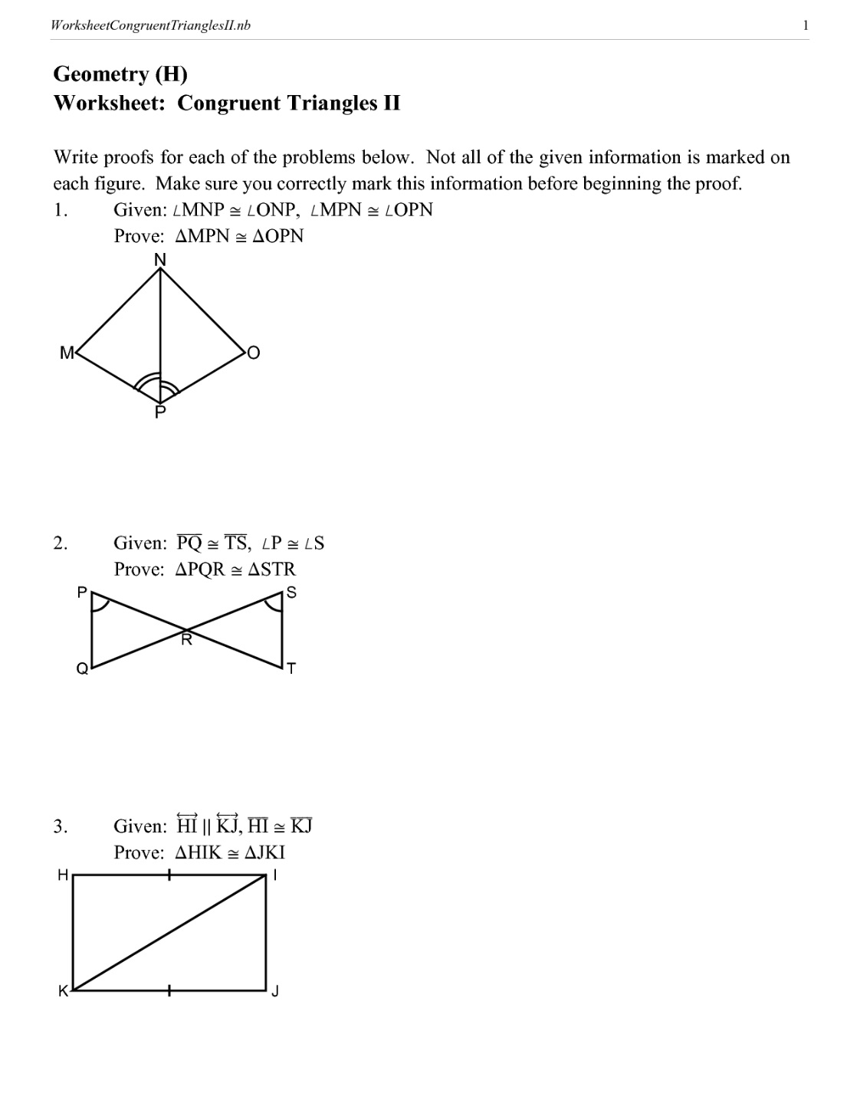Write a flow proof for the following:

20. Given: ∠MPN ≅ ∠OPN

22.

21.

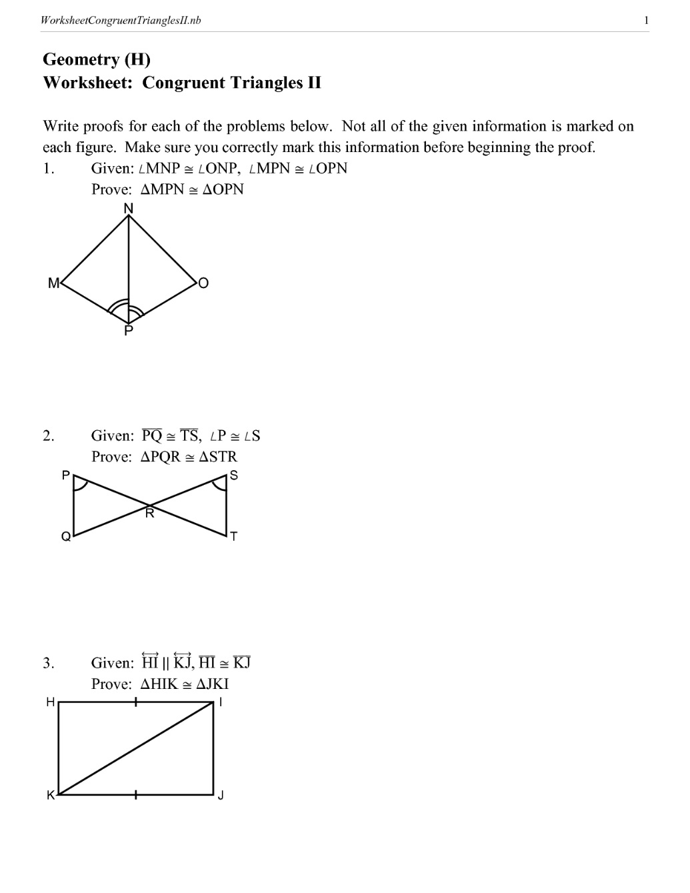 $\overline{NP}$ bisects ∠ MNO

Review Questions:

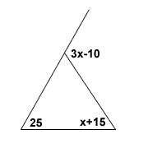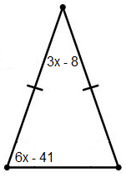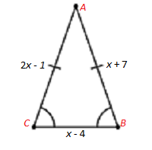Solve for x.

23. 24. 25.

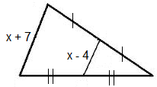26. 27.