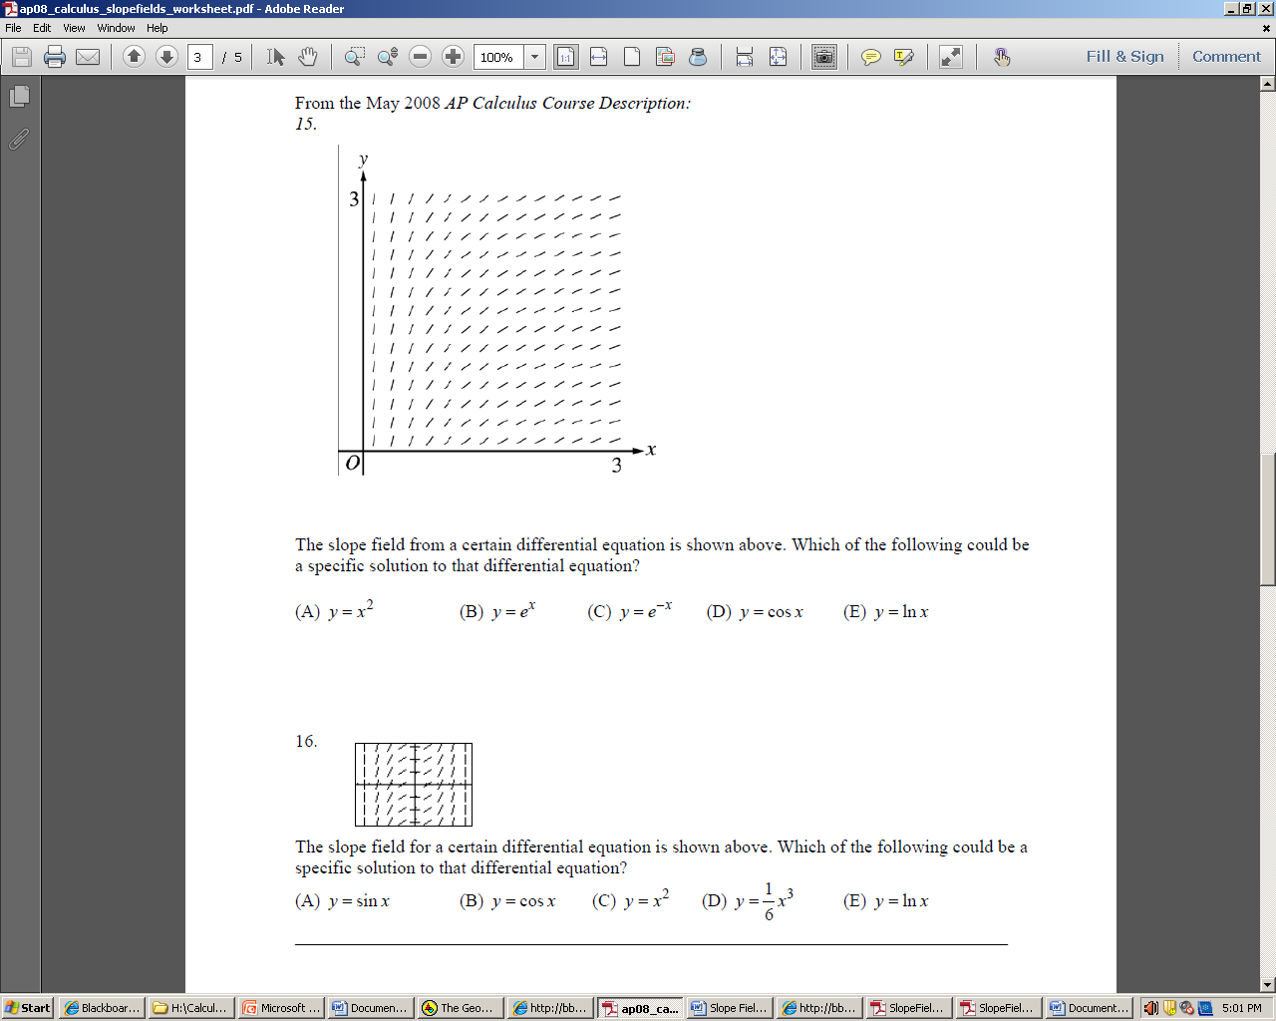**Multiple choice**

16. The solution to $\frac{dy}{dx}=-x$ with initial condition y(0) = 1

A. is always concave up

B. is always concave down

C. is undefined at x = 0

D. is always increasing

E. is always decreasing

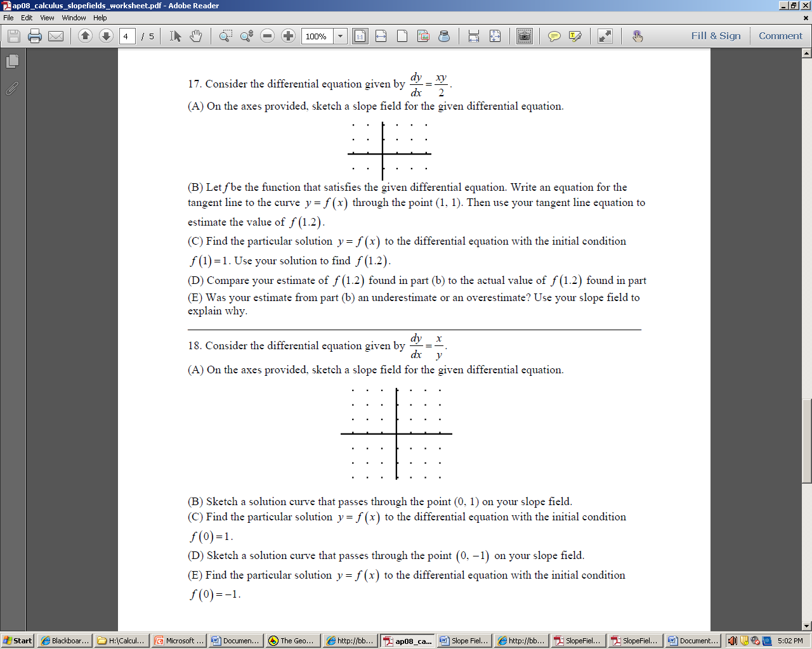**Free Response**