**Year Long Math 2 Name:________________________________**

**Unit 1 REVIEW: Transformations**

**SHOW ALL WORK!!!**

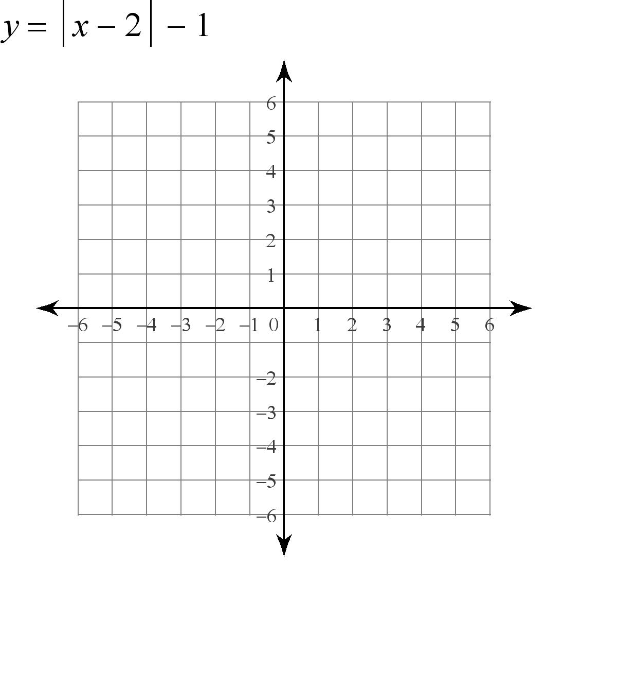1) The vertices of a triangle are A (0, 1), B (2, -6), and C (6, -6). Graph the image rotated 270º counter-clockwise around the origin. Name and label the image points.

A’___________ B’__________ C’ __________

A

C

B

Algebraic Rule: (x,y) → (_________, ____________ )

2) What is the algebraic rule for a translation of 2 units to the right and 9 units up?

________________

3) The vertices of a triangle are D (6, -1), E (6, 6), and F (1, 6). Graph the image reflected over the line y = -x. Name and label the image points.

D

F

E

D’___________ E’ __________ F’_________

Algebraic Rule: (x,y) → (_________, ____________ )

4) Find the image of A(-1, -2) and B(-9, 11) under a transformation (x, y) (x - 3, y + 5).

A’ _________ B’ ____________

5) **Graph** the points A (5, 3) and B(3, -2) and C(-2 , 1) and then rotate each 180˚ clockwise around the origin. Name and label the images.

A’___________ B’ ____________ C’ ___________

Algebraic Rule: (x,y) → (_________, ____________ )

6) Give an algebraic rule for the given transformation.

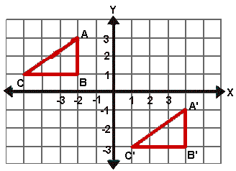

_____________________________________

7) Graph the image of triangle GHI with G(-3, -5), H(2, -5) and I(-3, -1) after a reflection over the y-axis. Name and label the image points.



G’ ________ H’ ________ I’ ________

G

I

H

Algebraic Rule: (x,y) → (_________, ____________ )

**Use for #8-9: Triangle JKL has vertices J (1, -2), K (5,-1), and L (3, 5).**

8) Graph the image of triangle JKL after a rotation of 90 degrees counterclockwise around the origin. Name and label the image points.

L

K

J

J’ ________ K’ ________ L’ ________

9) Graph the image of triangle JKL after a reflection over the line x = -1. Name and label the image points.

L

K

J

J’ ________ K’ ________ L’ ________

10) Quadrilateral MNOP has vertices M (6, -1), N (3, -3), O (0, -1), P (3, 4). Graph the image after a reflection over the x-axis. Name and label the image points.

P

M

N

O

M’ ________ N’ ________ O’ ________ P’ ________



11) Draw the line of reflection and write its equation.

_______________

12) State the type of transformation that maps figure A to figure given. (reflection, translation, or rotation)



1. A→B ___________________
2. A → C _____________________
3. A → D ____________________
4. A → E ______________________
5. A→ F ______________________
6. A→ G _____________________

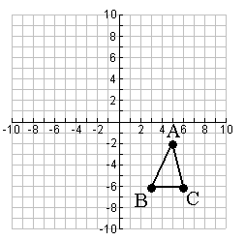

|  |  |
| --- | --- |
| 13) Graph the dilation image of rectangle ABCD, using a scale factor of 1/2 and the center of dilation at the origin.    B  A | 14) Rotate triangle ABC 90counterclockwise around the origin. Then reflect that image over the x-axis. Name and label the points after each transformation.  A’_________ B’ __________ C’__________  A”_________ B” __________ C”_________ |

D

C