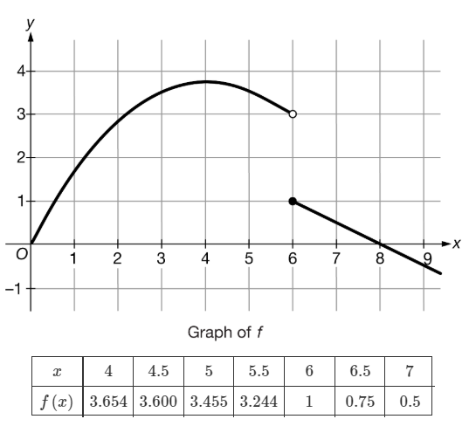
Name ________________________ Unit 2 – Derivatives Free Response Problem Set

The graph of the function f and a table of selected values of $f(x)$ are shown above. The graph of f has a horizontal tangent line at $x=4$, is concave down for $0<x<6$, and is linear for $x≥6$.
- (2 pts)Approximate the value of $f'(5.5)$ using the data from the table. Show the computations that lead to your answer.

- (2 pts) Is there a value of x, for $0<x<6$, such that $\lim_{x→0}{\frac{f\left(x+h\right)-f(x)}{h}}=0$? Show all work.

- (1 pt) Find the value, or explain why it does not exist. $\lim_{x→0}{\frac{f\left(6+h\right)-f(6)}{h}}$

