BC Unit 3 Parametric Equations and Vectors
 | Topic | Assignments
Day 1  Wed 2/13 | Sec 9.2 and 9.3 Parametric Equations  Graphing, Eliminating the Parameter,1st derivative | p.650 #1,3,9,15,17,23  p.657 #17,21,23 and describe the movement of the particle 31,35,39
Day 2  Thurs 2/14 | Sec 9.3 Parametric Eqns  2nd derivative, arc length | p.657 #5-13 odd,47-51 odd, 88-90
Day 3  Fri 2/15  Early Release | Quiz | Khan Academy Assignment due Feb 19th
Mon 2/18 | Teacher Workday
Day 4  Tues 2/19 | Review of Motion | Review of Motion Along a Line WS
Day 5 ACT  Wed 2/20 | Sec 9.6 Vectors | p.684 #5, 7-13 odd b only, 17-21 odd, 25, 35, 37
Day 6  Thurs 2/21 | 9.7 Vector Valued Functions | Day 4 Homework WS
Day 7  Fri 2/22 | More vector valued functions | Day 5 Homework WS  Khan Assignment due Feb 28th
Day 8  Mon 2/25 | Even More Practice with v-v functions | Day 6 Homework WS
Day 9  Tues 2/26 | Projectile Motion | Projectile Motion worksheet
Day 10  Wed 2/27 | Review | p. 703 #39-53 odd, 153-163 odd  p. 707 #1,4,6-9 p. 708 1,2
Day 11  Thurs 2/28 | Test (AP style) | Problem Set

Calculus Valentine's Day poem
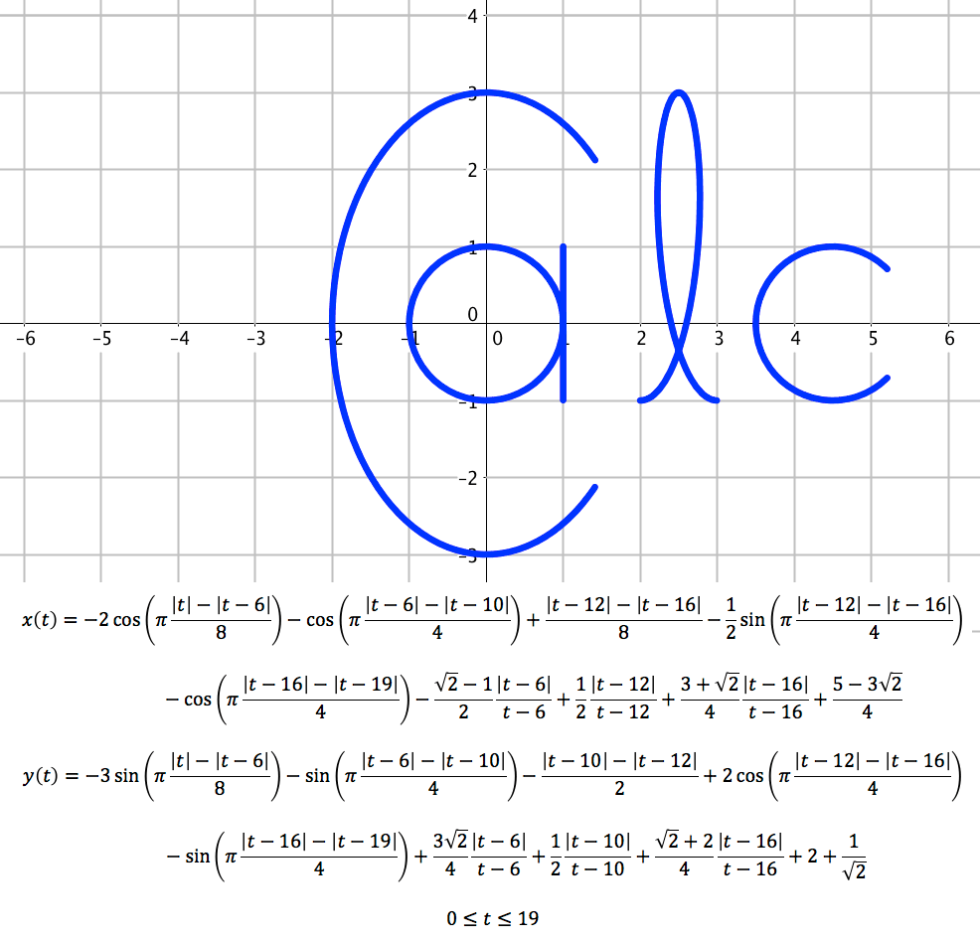
You pull my heart strings at a constant rate.
The three words I want to tell you, I cannot wait.
My love for you is not a partial fraction,
But rather, a whole lot of attraction.
In my heart, video games make their revolution.
I love them, but I’d rather have a u-substitution.
In this short life, my love for you is exponential.
The time I have now, I will use its max potential
To work for you who I truly desire.
Make no error, your love, I will acquire.

