C:\Documents and Settings\jmackey\Local Settings\Temporary Internet Files\Content.IE5\GTZSSUR0\MC900111366[1].wmf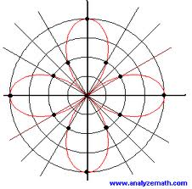BC Unit 4 Polar

Functions

|  |  |  |
| --- | --- | --- |
|  | Topic | Assignments |
| Day 1  Fri 3/1 | Review of Polar Coordinates Converting between rectangular and polar functions | Calculaugh 10  p. 668 #1-19 odd, 23, 27-41 odd |
| Day 2  Mon 3/4 | **Unit Circle Quiz**  Graphing Polar Functions | p.669 # 69 – 81 odd sketch graph only |
| Day 3  Tues 3/5 | Derivatives of Polar Functions | p.669 # #59 - 64 find equation of tangent line, 65, 67 |
| Day 4  Wed 3/6 | **Quiz**  Finding Tangents at the pole | p.669 # 69 – 75 odd 107, 108 |
| Day 5  Thurs 3/7 | Arc length | P 677 # 53 – 63 odd |
| Day 6  Fri 3/8 Early Release | Area | p.676 #1-17 odd, |
| Day 7  Mon 3/11 | Area between Curves | p.676 #12, 14, 19 – 25 odd, 37 - 45 odd, 77, 78 |
| Day 8  Tues 3/12 | Review | Review worksheet |
| Day 9  Wed 3/13polar cartoon.bmp | Test | Problem Set |