C:\Documents and Settings\jmackey\Local Settings\Temporary Internet Files\Content.IE5\GTZSSUR0\MC900111366[1].wmf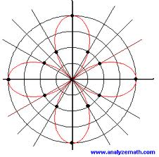BC Unit 4 Polar

Functions

|  |  |  |
| --- | --- | --- |
|  | Topic | Assignments |
| Day 1  Tues 3/10 | Review of Polar Coordinates Converting between rectangular and polar functions | Calculaugh 10  Sec 9.4 p. 668 #1-19 odd, 23, 27-41 odd |
| Day 2  Wed 3/11 | **Unit Circle Quiz**  Graphing Polar Functions | Sec 9.4 p.669 # 69 – 81 odd  sketch graph only |
| Day 3  Thurs 3/12 | Derivatives of Polar Functions | Sec 9.4 p.669 # #59 - 64 find equation of tangent line, 65, 67 |
| Day 4  Fri 3/13 | **Quiz**  Finding Tangents at the pole | Sec 9.4 p.669 # 69 – 75 odd 107, 108 |
| Day 5  Mon 3/16 | Arc length | Sec 9.5 P 677 # 53 – 63 odd |
| Day 6  Tues 3/17 | Area | Sec 9.5 p.676 #1-17 odd |
| Day 7  Wed 3/18 | Area between Curves | Sec 9.5 p.676 #12, 14,  19 – 25odd, 37 - 45 odd, 77, 78 |
| Day 8  Thurs 3/19 | Review | Review worksheet |
| Day 9  polar cartoon.bmpFri 3/20 | Test | Problem Set |